Importing libraries In [2]:
import

pandas

as

pd

import

matplotlib.pyplot

as

plt

import

seaborn

as

sns

import

numpy

as

np

# for the Q-Q plots

#import scipy.stats as stats

%
matplotlib
inline

import

pandas

as

pd

pd
.
options
.
display
.
float_format

=

'
{:.2f}
'
.
format

#from pandas.io.json import json_normalize

Loading dataset for Users In [3]:
users

=

pd
.
read_excel
(
"users.xlsx"
)

In [4]:
users
.
info
()

<class 'pandas.core.frame.DataFrame'> RangeIndex: 495 entries, 0 to 494
Data columns (total 7 columns): _id/$oid 495 non-null object active 495 non-null bool createdDate 495 non-null int64 lastLoginDate 433 non-null float64 role 495 non-null object signUpSource 447 non-null object state 439 non-null object dtypes: bool(1), float64(1), int64(1), object(4) memory usage: 23.8+ KB
In [5]:
users["lastLoginDate"] = users["lastLoginDate"].astype(str)
In [6]:
users
.
head
()

Out[6]:
_id/$oid active createdDate lastLoginDate role signUpSource s

0 | 5ff1e194b6a9d73a3a9f1052 | True | 1609687444800 | 1609687537858.0 | consumer | Email
1 | 5ff1e194b6a9d73a3a9f1052 | True | 1609687444800 | 1609687537858.0 | consumer | Email
2 | 5ff1e194b6a9d73a3a9f1052 | True | 1609687444800 | 1609687537858.0 | consumer | Email
3 | 5ff1e1eacfcf6c399c274ae6 | True | 1609687530554 | 1609687530597.0 | consumer | Email
4 | 5ff1e194b6a9d73a3a9f1052 | True | 1609687444800 | 1609687537858.0 | consumer | Email

Identifying numerical and categorical variables In [7]:
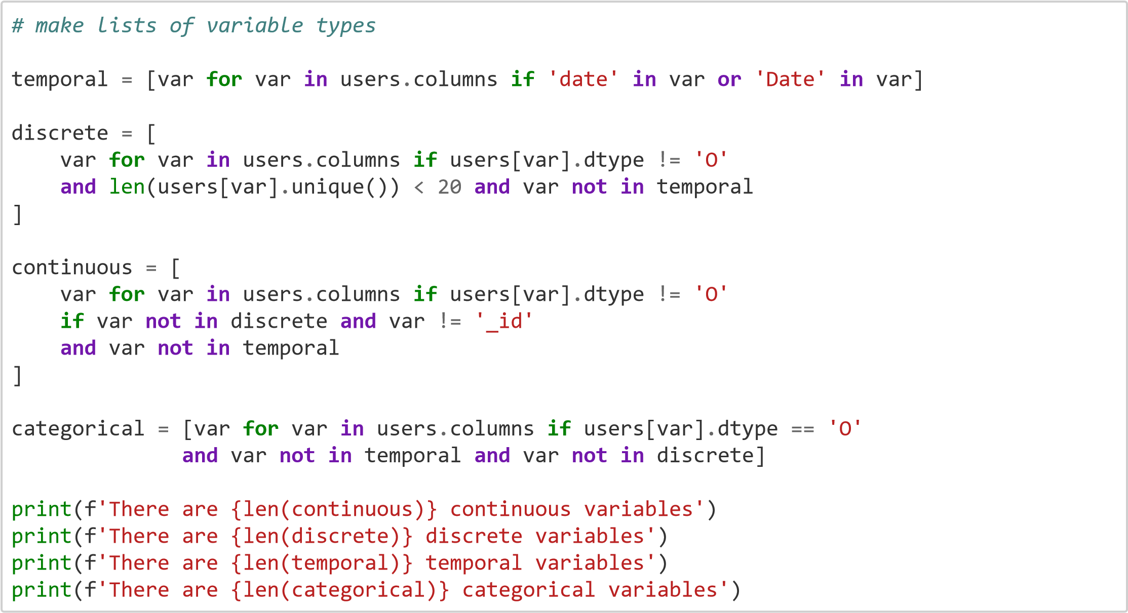
There are 0 continuous variables
There are 1 discrete variables
There are 2 temporal variables
There are 4 categorical variables
In [8]:
discrete

Out[8]:
['active'] In [9]:
temporal

Out[9]: ['createdDate', 'lastLoginDate'] In [10]:
categorical

Out[10]: ['_id/$oid', 'role', 'signUpSource', 'state']
Quantifying missing data In [11]:
users
.
isnull
()
.
sum
()

Out[11]:
_id/$oid 0 active 0 createdDate 0 lastLoginDate 0 role 0 signUpSource 48 state 56 dtype: int64
percentage of missing values in variables
In [12]:
# alternatively, we can use the mean() method after isnull() to visualise the percentage o f missing values for each variable percentage_null_values= users.isnull().mean() for key,value in percentage_null_values.items(): if value >0: print(key,":",value*100)
signUpSource : 9.696969696969697 state : 11.313131313131313
Checking for redundant records
In [13]:
duplicateRowsDF = users[users.duplicated()]
print("Duplicate Rows except first occurrence based on all columns are :") print(duplicateRowsDF)
Duplicate Rows except first occurrence based on all columns are :
_id/$oid active createdDate lastLoginDate \
- 5ff1e194b6a9d73a3a9f1052 True 1609687444800 1609687537858.0
- 5ff1e194b6a9d73a3a9f1052 True 1609687444800 1609687537858.0
- 5ff1e194b6a9d73a3a9f1052 True 1609687444800 1609687537858.0
- 5ff1e194b6a9d73a3a9f1052 True 1609687444800 1609687537858.0
8 5ff1e194b6a9d73a3a9f1052 True 1609687444800 1609687537858.0 .. ... ... ... ...
- 54943462e4b07e684157a532 True 1418998882381 1614963143204.0
- 54943462e4b07e684157a532 True 1418998882381 1614963143204.0
- 54943462e4b07e684157a532 True 1418998882381 1614963143204.0
- 54943462e4b07e684157a532 True 1418998882381 1614963143204.0
- 54943462e4b07e684157a532 True 1418998882381 1614963143204.0
role signUpSource state
- consumer Email WI
- consumer Email WI
- consumer Email WI
- consumer Email WI
8 consumer Email WI .. ... ... ...
- fetch-staff NaN NaN
- fetch-staff NaN NaN
- fetch-staff NaN NaN
- fetch-staff NaN NaN
- fetch-staff NaN NaN
[283 rows x 7 columns]
We have a considerately large number of redundant(duplicated) user records.
Unique values of categorical variables
Unique values:
In [14]:
users
[
"role"
]
.
unique
()

Out[14]:
array(['consumer', 'fetch-staff'], dtype=object)
In [15]:
users
[
"signUpSource"
]
.
unique
()

Out[15]:
array(['Email', 'Google', nan], dtype=object) In [16]:
users
[
"state"
]
.
unique
()

Out[16]: array(['WI', 'KY', 'AL', 'CO', 'IL', nan, 'OH', 'SC', 'NH'], dtype=object)
Examining percentage of different category values for categorical variables
In [17]:
freq_source = 100*(users['signUpSource'].value_counts() / len(users)) print(freq_source.map('{:,.2f} %'.format))
Email 89.49 %
Google 0.81 %
Name: signUpSource, dtype: object Dominant sign up source is Email.
In [18]:
freq_state = 100*(users['state'].value_counts() / len(users)) print(freq_state.map('{:,.2f} %'.format))
WI 80.00 %
NH 4.04 %
AL 2.42 %
OH 1.01 %
IL 0.61 %
CO 0.20 %
KY 0.20 %
SC 0.20 %
Name: state, dtype: object
As per this data, majority of the users that have signed up reside in Wisconsin.
Data quality issues found:
1. More than half of the user records(out of the total 495) are redundant.
Another, less pressing issue:
1. small percentage of missing values in signUpSource and state columns

